**TERM WORK - V**

**EMPLOYEE DATABASE**

CONSTRUCT THE DATA BASE FOR EMPLOYEE IN COMPANY

**EMPLOYEE**(F_name: String,L_name: String.M_name: String,SSN: Number,Birthdate,Address: String, Sex: String,Salary: Number)

**DEPARTMENT**(Dno: Number, Dname: String, Mge_Ssn: Number, Mgr_Start_Date:Date)

**DEPT_LOCATION(**Dno: Number, Dlocation: String**)**

**PROJECT**(Pname: String, Pnumber: Number, Plocation: String, Dno: Number**) WORKS_ON(**SSN: Number, Pno: Number, Hours: Number**)**

**DEPENDENT(**SSN: Number, Dependent_Name: String, Sex: String, Bdate: Date, Relationship: String)

1. Draw ER & Schema Diagrams for the Database.
2. Create the tables by properly specifying the primary keys and foreign keys.
3. Enter at least five tuples for each relation.
4. Retrieve all distinct salary values
5. Retrieve all employees in department 2 whose salary is between 10,000 and 20,000
6. For each department, retrieve the department number, the number of employee in the department, and their average salary.
7. For each project, retrieve the project number, the project name, and the number of employees who work on that project
8. List employee complete name, department number who does not belong to department no-2.
9. **Draw ER & Schema Diagrams for the Database**

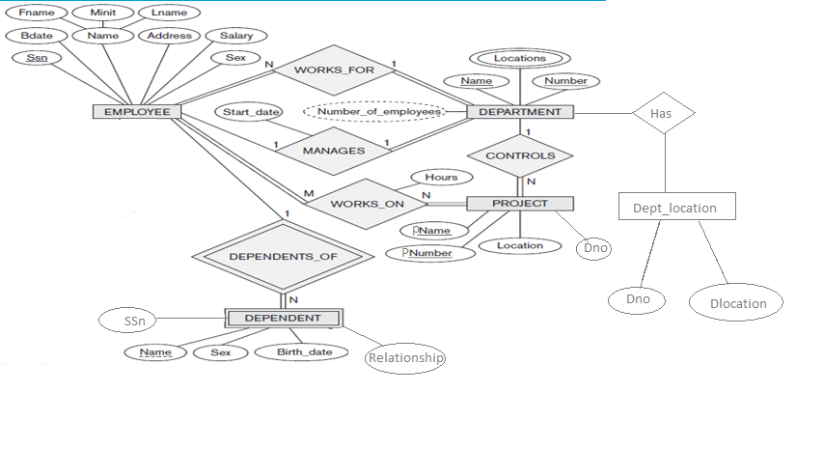

**Schema Diagram:**

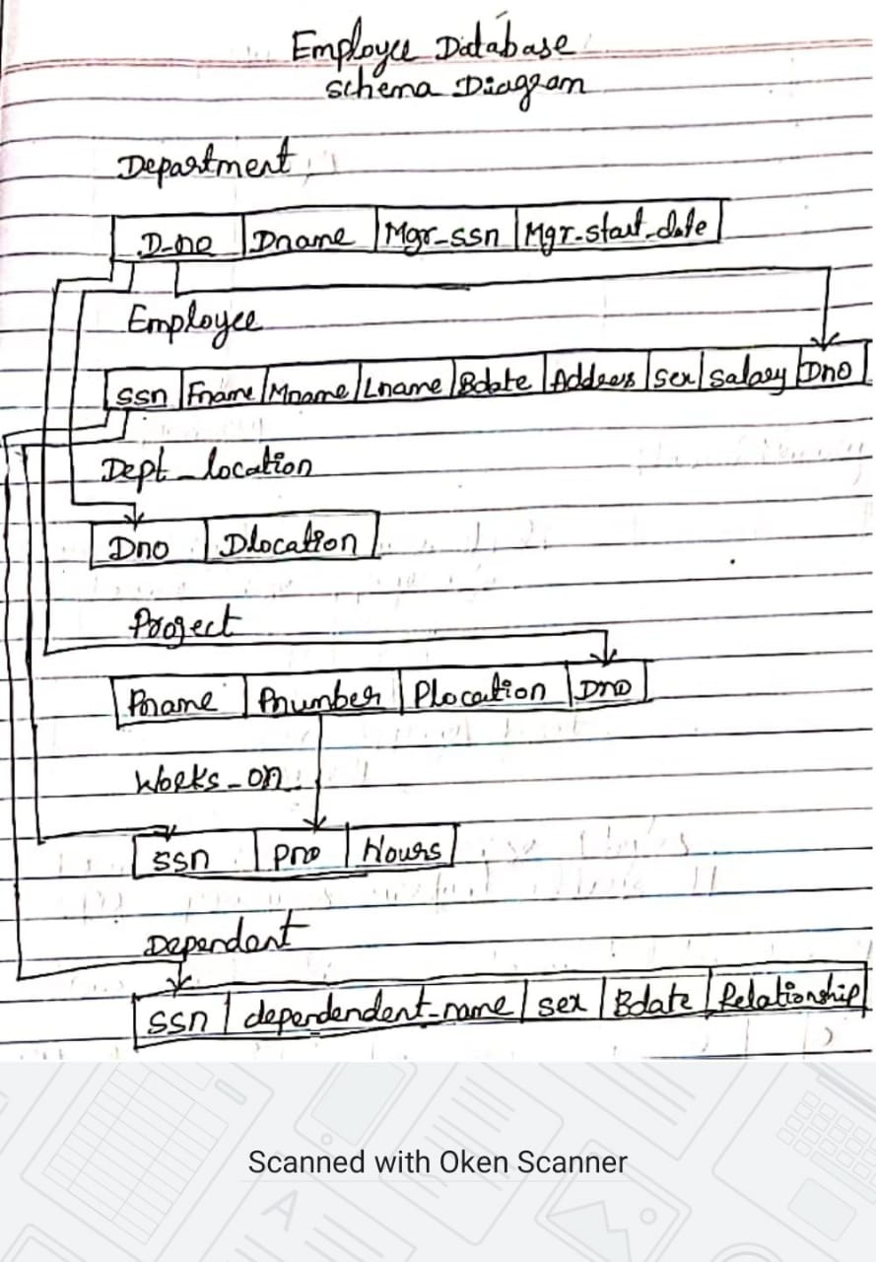

1. **Create the tables by properly specifying the primary keys and foreign keys**

Create table department

(dno number(4) primary key,

Dname varchar(15),

Mgr_ssn number(4),

Mgr_start_date date);

Create table employee

(ssn number(5) primary key,

Fname varchar(20),

Mname varchar(20),

Lname varchar(20),

Bdate date,

Address varchar(20),

Sex varchar(2),

Salary number(10),

Dno number(4)references department(dno));

Create table dept_location

(dno number(4) references department(dno),

dlocation varchar(10));

Create table project

(pname varchar(10),

Pnumber number(4) primary key,

Plocation varchar(10),

Dno number(4)references department(dno));

Create table works_on

(ssn number(4) references employee(ssn),

pno number(4) references project(pnumber),

hours number(4));

Create table dependent

(ssn number(4) references employee(ssn),

dependent_name varchar(20),

sex varchar(4),

bdate date,

relationship varchar(20));

**Description of all tables:**

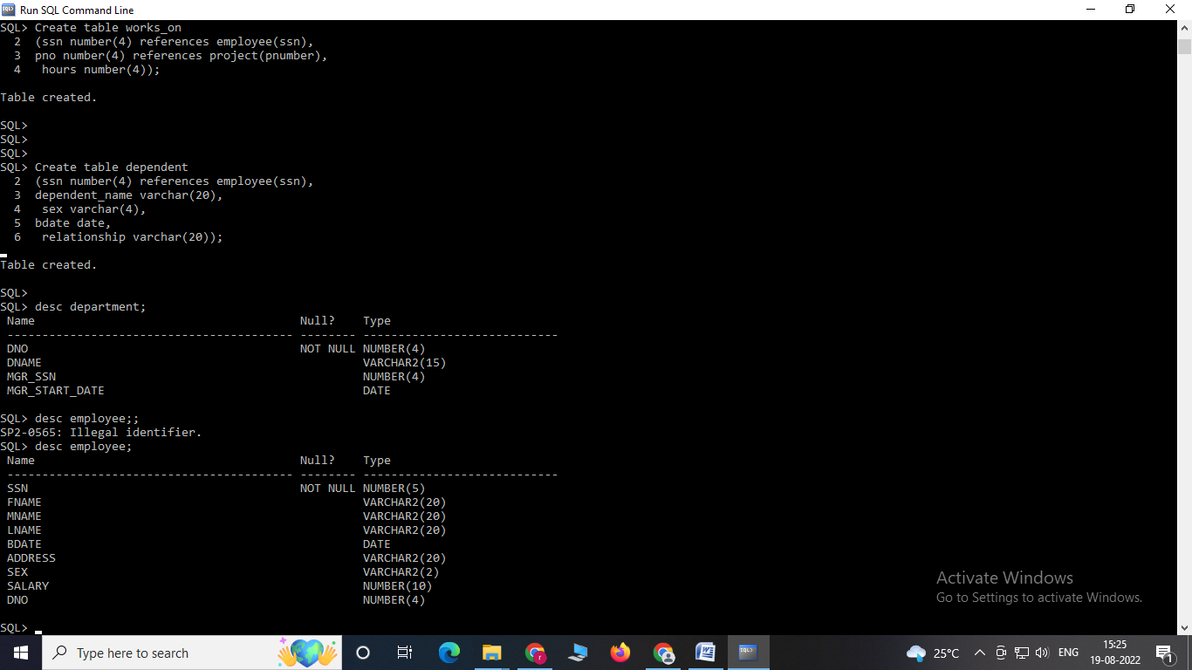



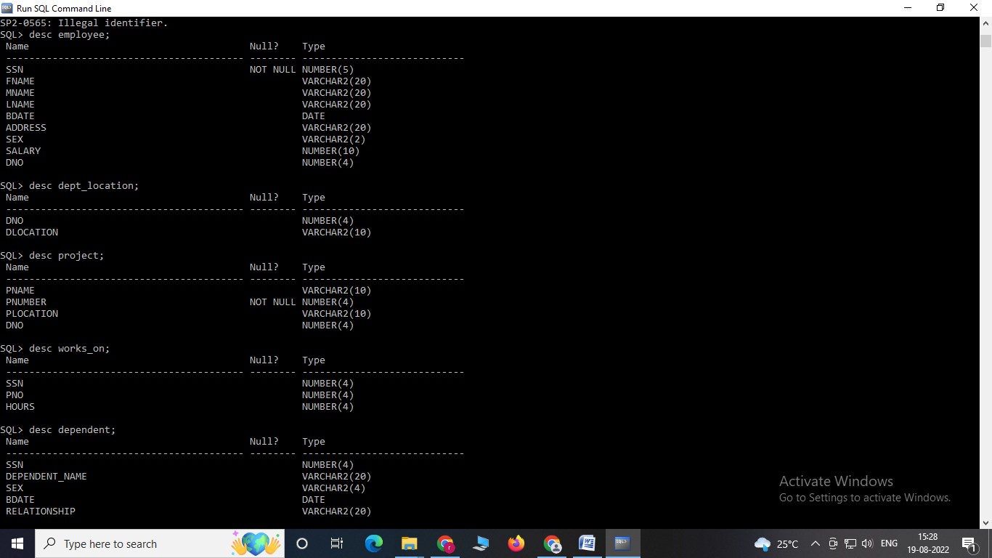

1. **Enter at least five tuples for each relation**

Insert into department values(1,'testing',100,'10-dec-15');

Insert into department values(2,'development',101,'10-jan-10');

Insert into department values(3,'hr',102,'10-oct-12');

Insert into department values(4,'marketing',103,'10-dec-90');

Insert into department values(5,'accounts',104,'23-dec-17');

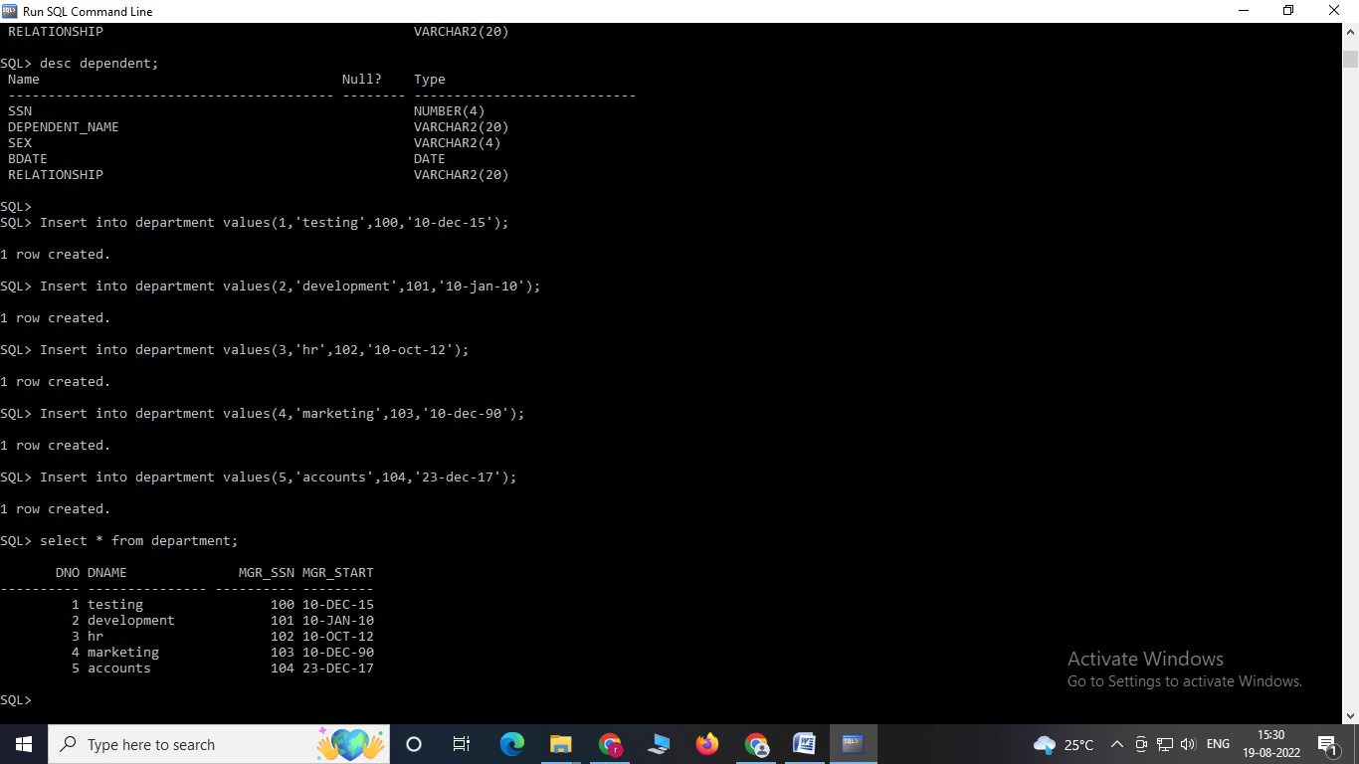

Insert into employee values(100,'aashish','a','kumar','1-jan-17','banglore','m',10000,1);

Insert into employee values(101,'ajay','b','patil','20-sep-21','manglore','m',20000,2);

Insert into employee values(102,'sudeep','d','kundagol','10-jan-22','hubli','m',25000,2);

Insert into employee values(103,'manju','s','pateel','15-aug-19','dharwad','f',12000,3);

Insert into employee values(104,'arya','m','singh','19-sep-21','mumbai','m',25000,4);

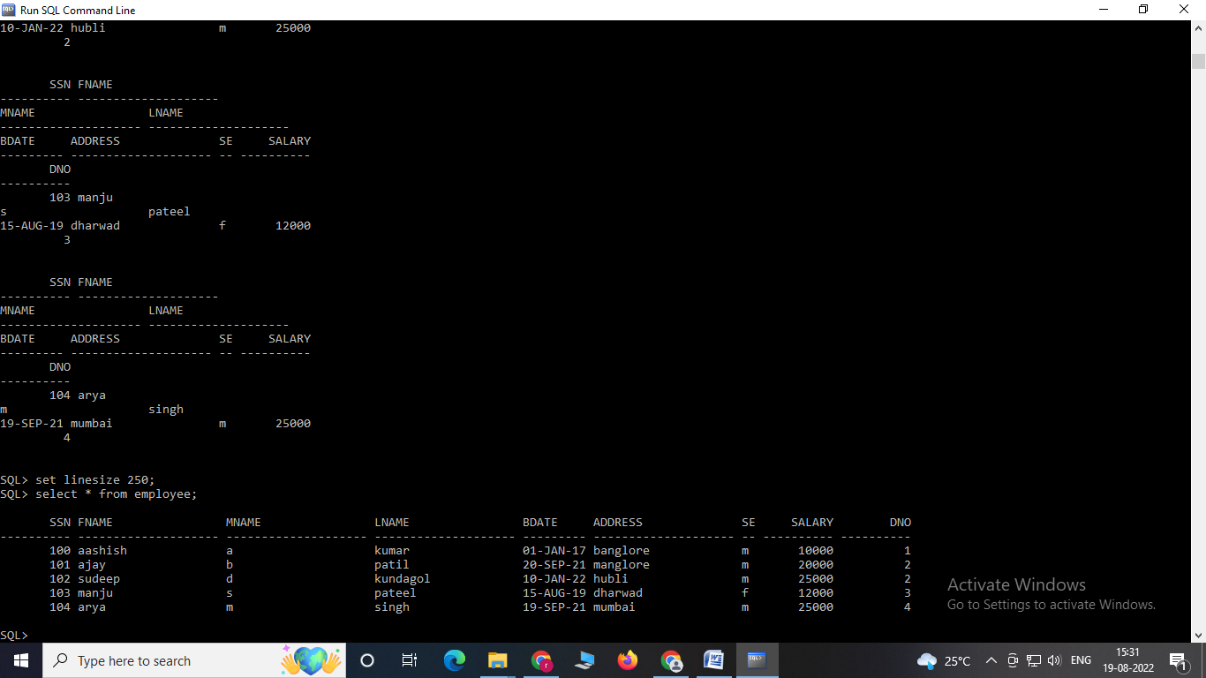

Insert into dept_location values(1,'manglore');

Insert into dept_location values(2,'banglore');

Insert into dept_location values(3,'hubli');

Insert into dept_location values(4,'dharwad');

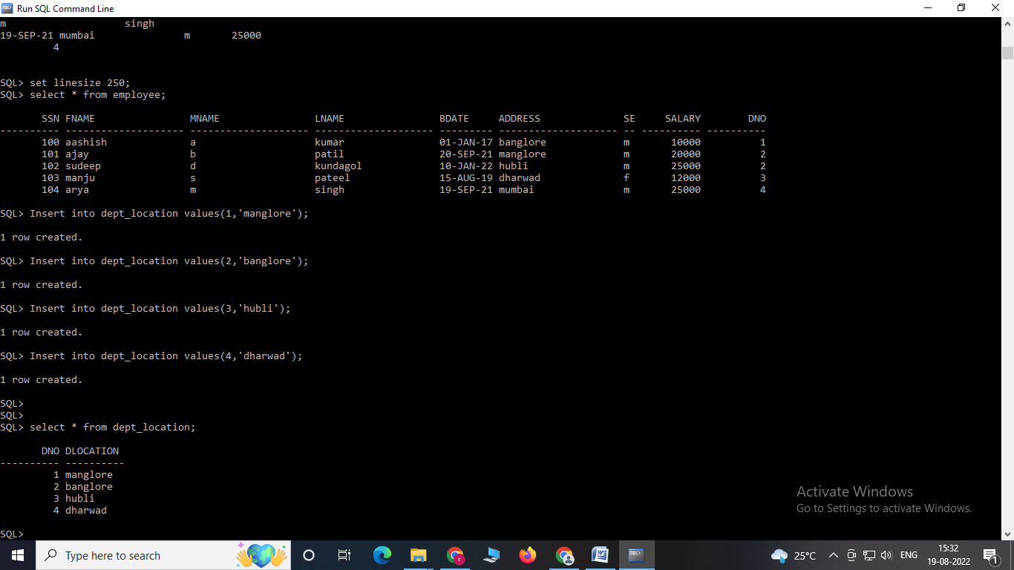

Insert into project values('mercury',222,'hydrabad',1);

Insert into project values('skyhawks',223,'banglore',2);

Insert into project values('coastline',224,'pune',3);

Insert into project values('harvest',225,'mumbai',4);

Insert into project values('greengrow',226,'mumbai',4);

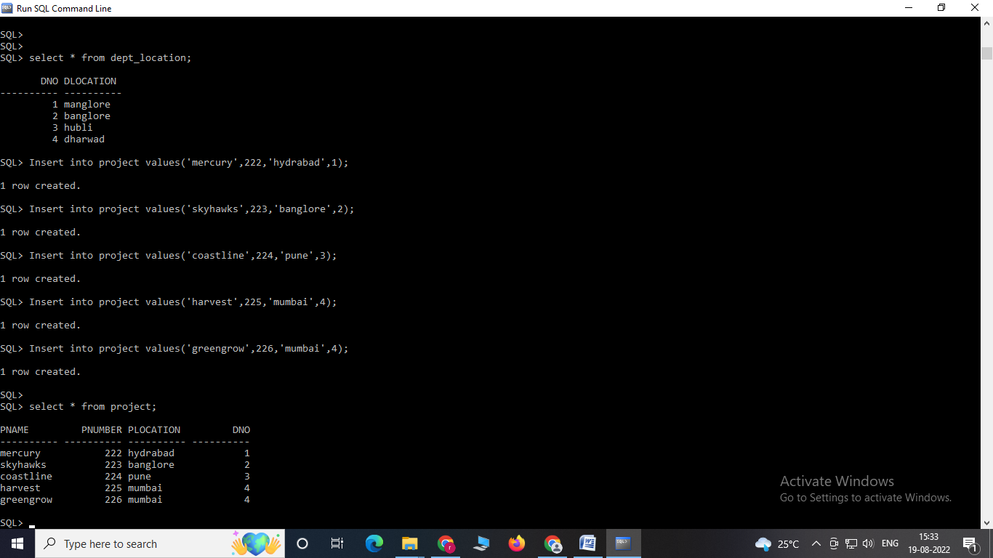

Insert into works_on values(100,222,120);

Insert into works_on values(101,223,160);

Insert into works_on values(102,224,180);

Insert into works_on values(103,225,60);

Insert into works_on values(102,224,180);

Insert into works_on values(102,224,185);

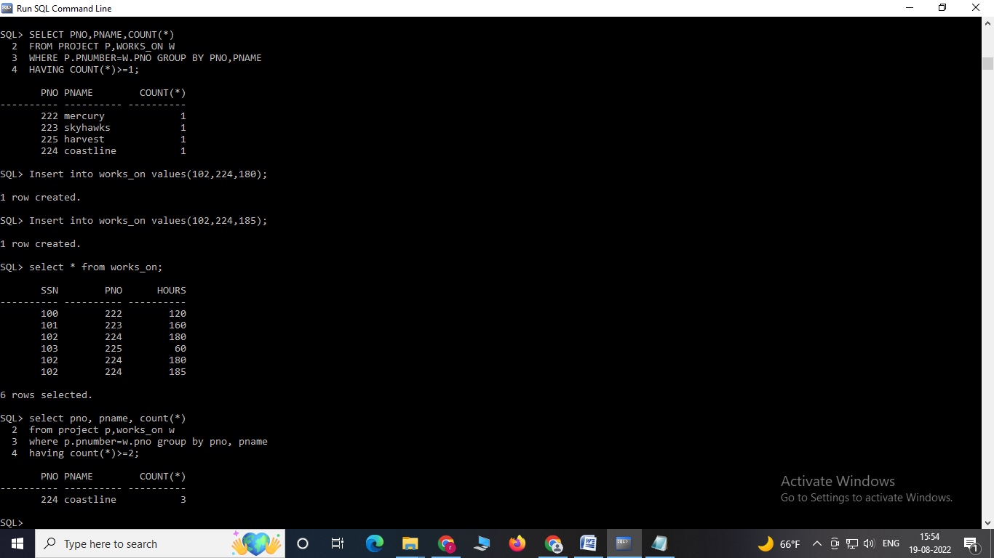

Insert into dependent values(100,'akshatha','f','10-oct- 90','daughter');

Insert into dependent values(101,'ajay','m','10-oct-90','son');

Insert into dependent values(102,'kiran','male','10-oct-90','son');

Insert into dependent values(103,'manish','male','10-oct- 90','father');

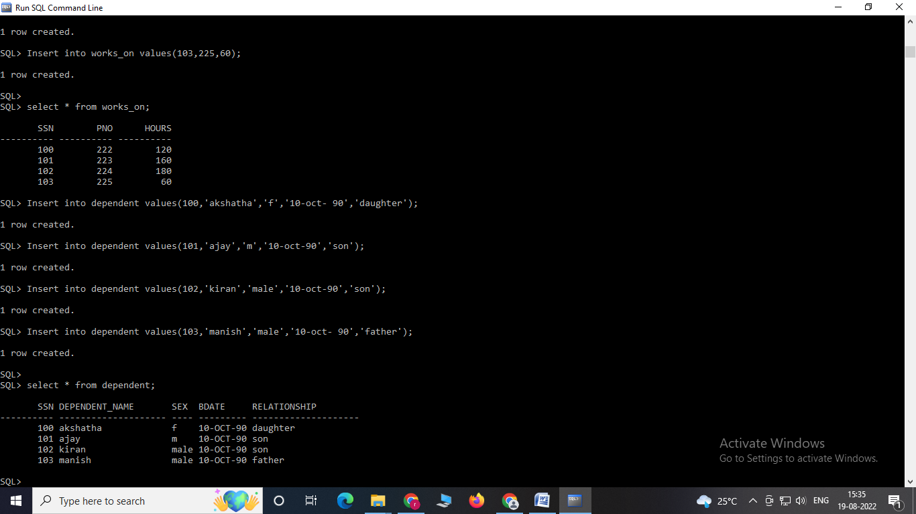

**QUERIES:**

**4. Retrieve all distinct salary values**

select distinct salary from employee;

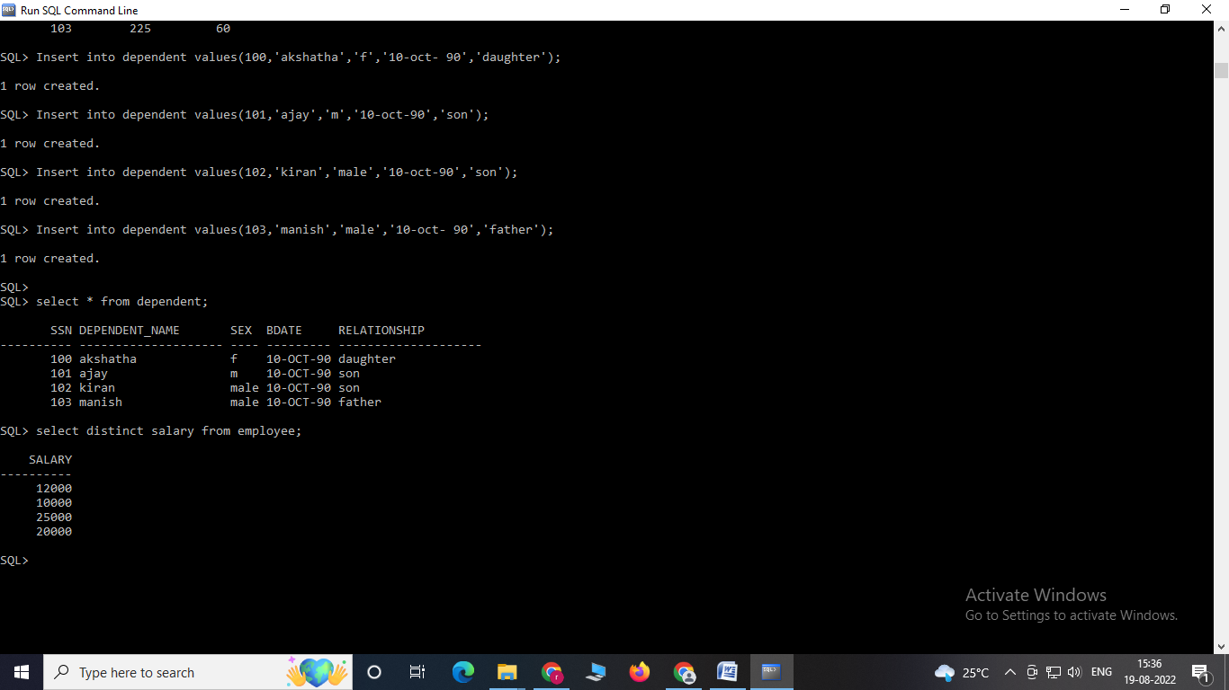

**5. Retrieve all employees in department 2 whose salary is between**

**10,000 and 20,000**

select * from employee where dno=2 and salary >=10000 and salary<=20000;

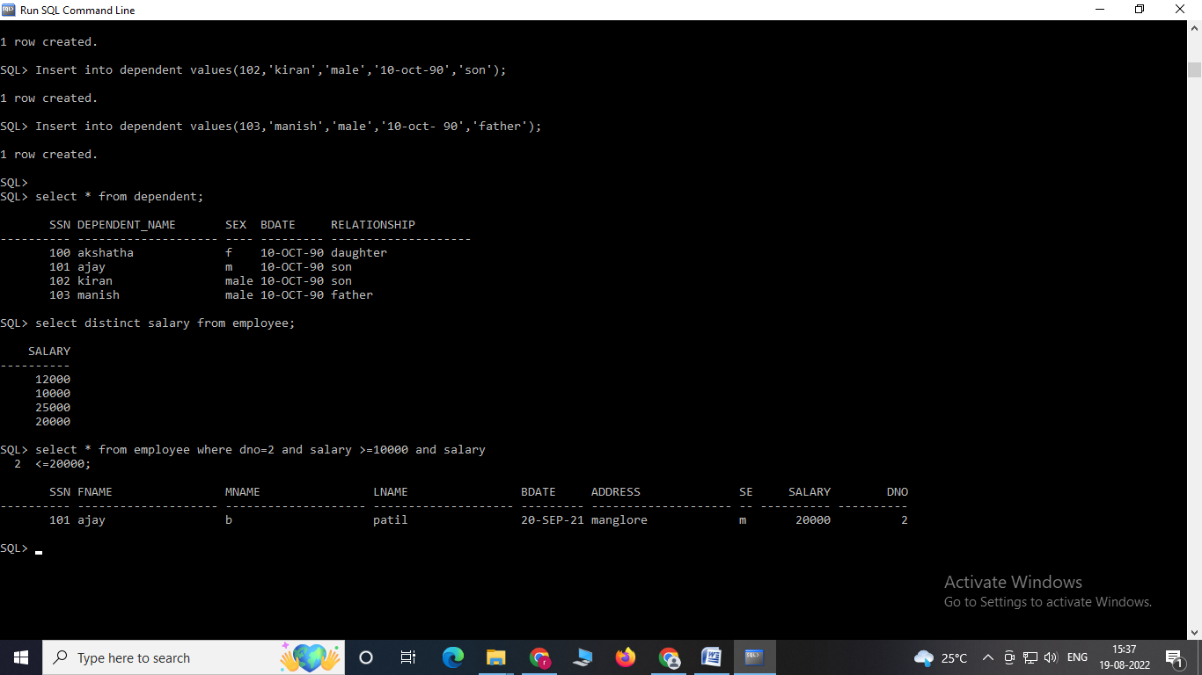

**6. For each department, retrieve the department number, the number of e mployee in the department, and their average salary.**

select dno, count(*), avg(salary)

from employee

group by dno;

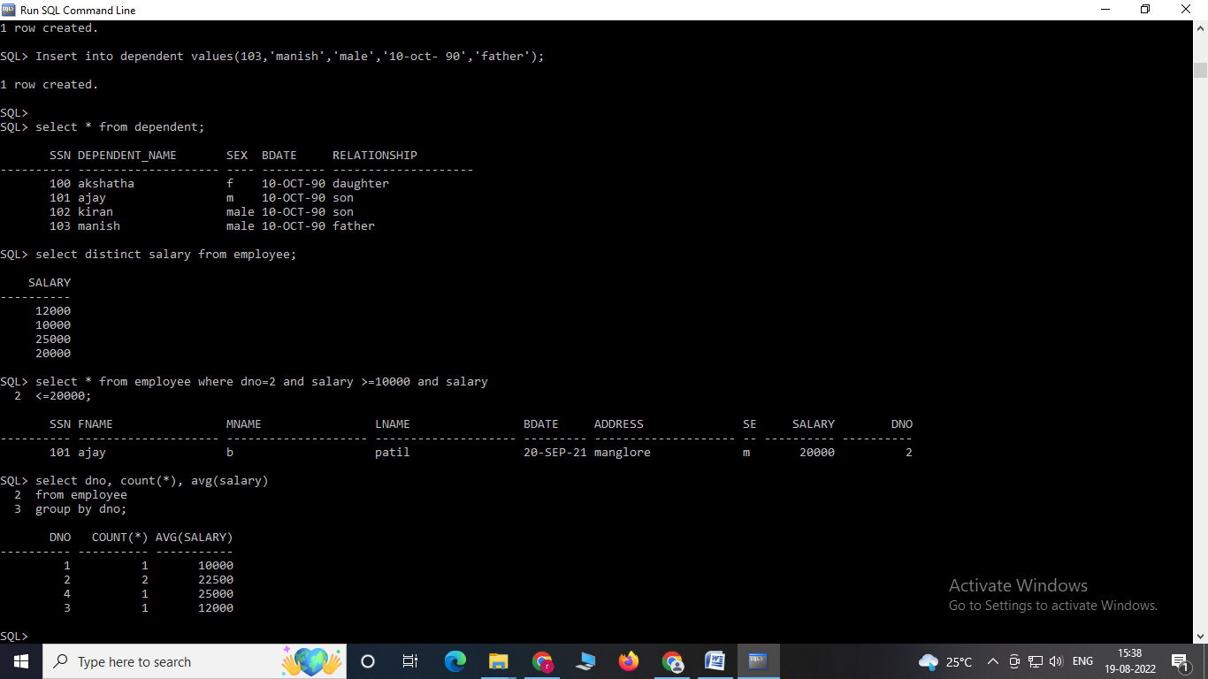**7. For each project, retrieve the project number, the project name, and the number of employees who work on that project**

select pno, pname, count(*)

from project p, works_on w where

p.pnumber=w.pno

group by (pno, pname);

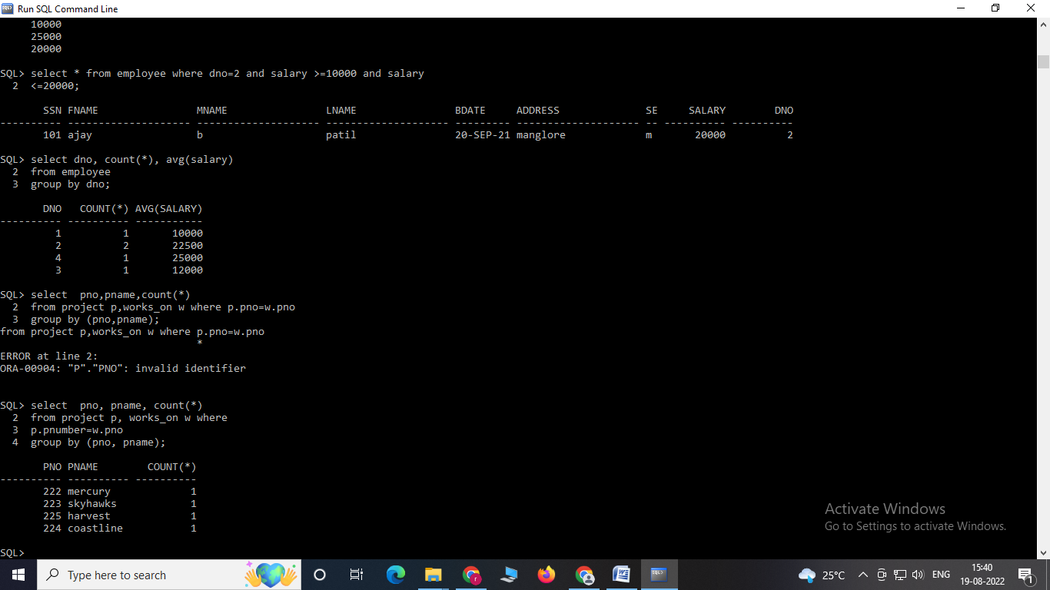

**8. List employee complete name, department number who does not belong to department no-2.**

SELECT fname, mname, lname, dno from employee WHERE dno <>2;

